Video Puzzle

By Xizheng Ding

**Please put a “video.mp4” under the root folder to start the game**

**Or use the video that I uploaded to desire to learn…**

1. After loading Video

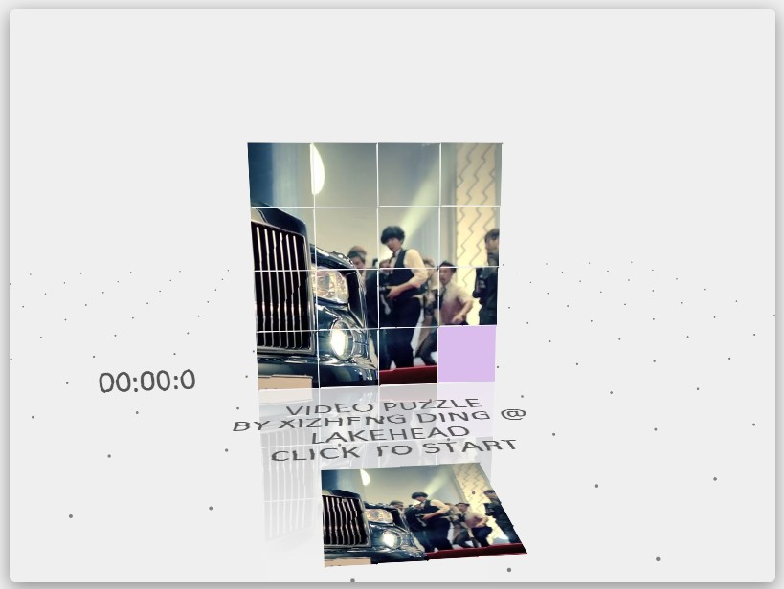

1. Press **Left** or **Right** Key to change Game Levels…

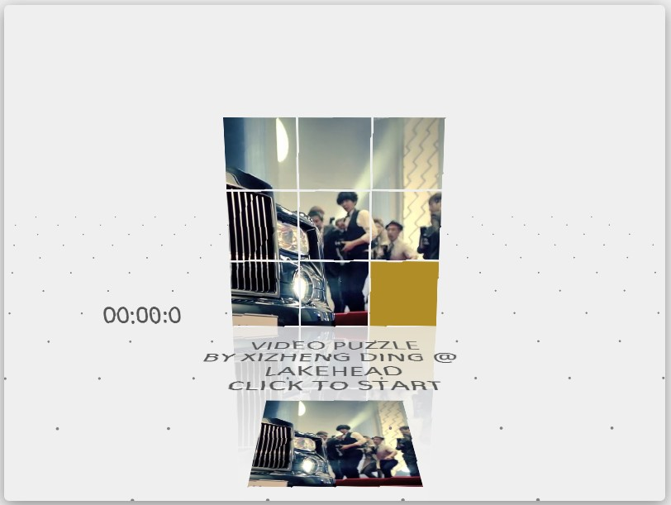

1. Then click to start the game…

